Summary of research proposal
Estuaries are coastal regions characterised by complex hydrodynamics, involving mixing of fresh and saline water, tidal motion and river flow. This results in transport and entrapment of sediments. Trapping locations (estuarine turbidity maxima, ETM) are sensitive to variations in external forcing (storms, sea level rise, river flooding), site-specific bathymetry (islands, navigation channels, shoals) and sediment characteristics.
Striking examples of ETM featuring such variations (of both natural and anthropogenic origin) are the Pearl River Estuary (PRE), China, and the Ems Estuary, Netherlands/Germany. Understanding ETM dynamics and the sensitivity to changing conditions is important for estuarine management (maintenance of navigational channels, water quality and ecology). The complex bathymetry of PRE, a two-channel system with several islands and four tributaries, makes ETM dynamics inherently three-dimensional. As previous research primarily focused on variability in either the longitudinal or transverse direction, current modelling expertise is unable to unravel the interwoven longitudinal and transverse turbidity structure.
Our goal is to investigate/understand the formation of ETM and its sensitivity to forcing, bathymetry and sediment characteristics in estuaries. The innovation is twofold: (1) a detailed understanding of the combined influence of lateral and longitudinal trapping, (2) application to site-specific problems in PRE.
We adopt an integrated approach, involving three key aspects: idealized modelling, numerical modelling and field data. Idealized models, including the essential physical processes and large-scale geometrical/bathymetrical features in a simplified way, are specifically geared to unravel trapping mechanisms. Numerical models, including state-of-the-art process formulations, extend these results to transient forcing conditions and aspects specific for PRE. Field data serve as input and validation for both models. Since detailed data in the PRE are lacking, new field measurements will be conducted.
This joint Chinese/Dutch project helps to gain insight in ETM dynamics in the Pearl River Estuary and other estuaries in the world.

Key Words: Estuarine Turbidity Maximum (ETM); Pearl River Estuary; Human intervention; Idealized and numerical modelling; field measurements.

Research programme

Introduction
Estuaries are the connections between the marine and riverine environments. Examples are the Pearl River Estuary and the Yangtze estuary in China, the Ems estuary on the Dutch-German border, the Scheldt estuary on the Dutch–Belgium border, the Humber in the UK, the York River in the US and many others. The water motion in the estuary is forced by time–varying freshwater inflow (typically 10-10³ m³∙s⁻¹) and regular tidal movement of salty seawater. Secondary currents are generated by nonlinear processes within the estuary (Parker, 1991), the spatial and temporal salinity distribution (Simpson et al., 1990) and the interaction of the tide with the irregular topography (Zimmerman, 1980). The water motion induces a transport of sediment and, due to erosion–deposition processes, a time–varying topography (see Schuttelaars & De Swart, 1999; Seminara & Tubino, 2001; Van der Wegen & Roelvink, 2008).
This proposal focuses on a striking aspect observed in many estuarine systems: at specific locations the concentration of suspended sediment reaches a local maximum. This phenomenon is called an estuarine turbidity maximum (ETM). Sediment concentrations at these locations range from tens of mg/l to tens of g/l, depending on the specific estuary. The occurrence of ETM has both economic (e.g. siltation of shipping lanes and harbors) and ecological implications (e.g. negative impact of the turbidity on light availability). To be able to manage the various effects of ETM, there is strong need to understand, model and predict the ETM dynamics and their response to changing conditions.
In the literature, several mechanisms that generate ETM have been proposed, mostly focusing on longitudinal trapping mechanisms. Only recently lateral trapping mechanisms have been studied. The longitudinal trapping mechanisms cover almost the entire spectrum of estuarine hydrodynamic processes. Relevant barotropic processes are tide–topography interaction (Ianniello, 1979; Allen et al., 1980) and wind forcing (Weir & McManus, 1987). Other mechanisms resulting in particle trapping are tidal asymmetry, spatial and temporal settling lags (de Swart & Zimmerman, 2009, and references therein). Baroclinic processes resulting in particle trapping are related to the presence of residual gravitational circulation and so–called tidal mixing asymmetry. The first mechanism puts emphasis on the convergence of sediment near the bed of the residual landward–directed gravitational circulation and seaward–directed river flow (e.g., Hansen & Rattray, 1965). The effect of tidal mixing asymmetry on ETM dynamics was first described in Geyer (1993). In moderately and highly stratified estuaries, the reduction in turbulent mixing due to salt stratification reduces the sediment transport capacity of the flow, causing sediment to be trapped near the landward limit of the salinity intrusion (Jay & Musiak, 1994; Burchard & Baumert, 1998; Stacey et al., 2001, 2008). Apart from these mechanisms, Lang et al. (1989) included the effect of sediment availability by prescribing a longitudinally varying erosion coefficient. Furthermore, particle aggregation results in an enhanced trapping of sediment (Eisma, 1986; Wolanski & Gibbs, 1995). Trapping of sediment in the lateral direction has been investigated first by Huijts et al. (2006) and been extended by Chen & Sanford (2009a, b), Schramkowski et al. (2010).
Previous research has pointed out that the transverse distribution of water motion and sediment concentration significantly affects the longitudinal momentum balance and transport of material in many estuaries (Geyer et al., 1998; Kim & Voulgaris, 2008). Therefore, to understand the physical mechanisms resulting in trapping of sediment, it is not enough to study either the longitudinal or lateral processes, but the interaction between these processes has to be studied as well. This requires a three dimensional modeling approach. Furthermore, in the case of complex geometries/bathymetries, the ETM dynamics is inherently three-dimensional. An example of such a complex system is the Pearl River Estuary, which will be described in detail in the next section.

Overall aim
Our overall aim is to investigate/understand the three-dimensional aspects of ETM dynamics in estuaries such as the Pearl River Estuary. Specific aims will follow after the description of Pearl River Estuary (next Section).

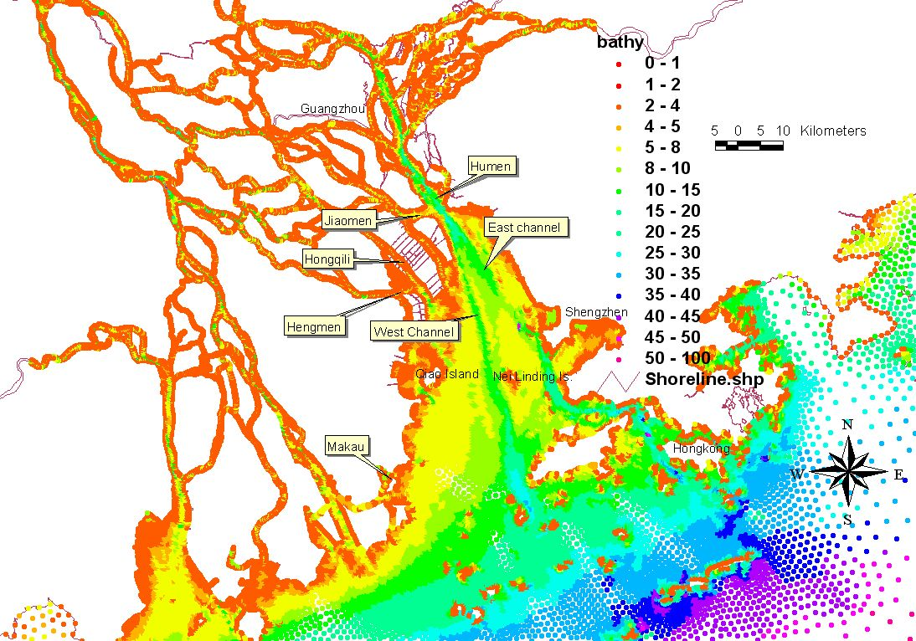Figure 1. Bathymetry of the Pearl River Estuary.

Description of the key area
The Pearl River Estuary covers an area of about 1900 km². Three shoals of less than 2 m deep, namely the East, Middle and West Shoal are separated by two natural waterways of more than 5 m flow depth, namely the East channel and the West channel, which merge near the Humen outlet. The West Shoal is the largest one, which is adjacent to the other three Pearl River outlets, namely Jiaomen, Hongqimen and Hengmen from North to South, respectively. These four outlets discharge freshwater, sediment and pollutants into the estuary. The mean annual flow rates from the four outlets (from North to South) are about 1910, 1790, 663 and 1158 m³∙s⁻¹, respectively. The suspended sediment concentration is lower than in other major rivers in China with a mean concentration of about 0.172 kg∙m⁻³ and an annual flux of about 30.64 million tons. About 92–96% of the suspended sediment is discharged during the wet season, about 80% of the input sediment deposits within the Pearl River Estuary and the remaining is transported to the South China Sea (Xu et al. 1985). The general sediment classes in the deeper regions (water depth larger than 5 m) and in the shoal regions of the Pearl River Estaury are silty sand (size larger than 63 μm) and silty clay (size less than 63 μm), respectively. The estuary is partially mixed and the tide is asymmetric. The average tidal range is about 2.0 m, and the largest tidal range is 3.66 m.
Studies concerning the ETM dynamics in the Pearl River Estuary (e.g., Tian, 1986; Chen et al., 1999; Ni et al., 2000; Wai et al., 2004; Wang 2006) included both observational and numerical modeling. However, these studies are based on a limited amount of data or two-dimensional depth-averaged (2DH) numerical modeling. Hence, the in-depth understanding of ETM dynamics is lacking, as this dynamics is inherently three-dimensional and varies significantly over different temporal and spatial scales. For example, ETM variability over intra-tidal, fortnightly, seasonal and larger time scales has not been resolved. Moreover, most studies focused on the situations under regular forcing conditions, not exploring the effects of extreme events, like Typhoons and river flooding. Furthermore, the importance of local circulation induced by island sheltering or lateral bathymetric irregularity on ETM formation has not been understood. In addition, it has been reported that there exists a layer of fluffy mud between the water column and seabed in the estuary, which is likely to impact the sediment resuspension and deposition.
Apart from these natural processes, the effects of human activities may significantly impact the morphodynamics of the coastal environment (Roos et al., 2008). Examples relevant to Pearl River Estaury include navigation channel dredging, land reclamation and sand mining. These types of intervention may significantly affect ETM dynamics, and need to be understood more thoroughly.

Specific aims
As pointed out in the previous section, ETM dynamics in the Pearl River Estuary is clearly a three-dimensional phenomenon. As suggested by for example Geyer et al. (1998) this is likely the case in many estuaries. The interaction of lateral and longitudinal processes and their relative importance concerning the formation of ETM have not been studied systematically before. Furthermore, a systematic study of the response of ETM dynamics to changing conditions is lacking. These considerations set the specific aims of our proposal:

- To analyze three-dimensional mechanisms resulting in the trapping of sediment for different estuarine geometries/bathymetries under regular forcing conditions, assuming morphodynamic equilibrium. The Pearl River Estuary and the Ems Estuary serve as prototype examples.
- To investigate the sensitivity of equilibrium ETM dynamics to different wind forcing, river discharges and geometrical/bathymetrical features (resulting from sand mining, navigation dredging and land reclamation). Such changes represent extreme events and human interventions typical for the Pearl River Estuary.
- To evaluate the temporal evolution of ETM dynamics under changing conditions, i.e. the transient/non-equilibrium behaviour associated with storm and flooding events as well as human interventions.

Methodology and plan of work
To achieve the specific aims explained above, we adopt an integrated approach based on three distinct methods that support each other:

- Field measurements
- Idealized modelling
- Numerical modelling.

In idealized models, geometry, forcing and physical processes are simplified, retaining only the aspects that are essential for the phenomenon under study. The main advantage of this approach is that these models can be systematically analyzed and sensitivity studies can be easily performed, yielding insight in the relevant physical processes. This type of models is particularly suited to address the specific aims A1-A2; due to the morphodynamic equilibrium assumption aim A3 cannot be addressed. The results obtained with the idealized models must be compared with field data and complex models. A comparison with field data yields insight in the correctness of the approximations and simplifications made in the model. The inter–model comparison is a valuable tool to validate complex numerical models using the physical insight gained with the idealized models. Complex numerical models are specifically suited to address aim A3, as they can deal with detailed descriptions of physical processes and geometry/bathymetry (island, land reclamation, sand mining, navigation dredging), without the restriction of morphodynamic equilibrium. The availability of field data is essential to assess the quality of the numerical model.
This approach has already proven to be highly successful in the modeling of tidal embayments. Results from an idealized barotropic model (Schuttelaars & De Swart, 2000) showed good agreement with complex numerical model results (Hibma et al., 2003) and field data from the Western Scheldt. Regarding baroclinic models, Huijts et al. (2006) successfully modeled lateral entrapment of sediment in tidal estuaries. The results compared favorably with numerical model results by Schramkowski et al. (2010) and data from the James River Estuary. Following the approach of Festa & Hansen (1978), Talke et al. (2009) developed a width- and tidally averaged analytical baroclinic model of longitudinal sediment trapping. Chernetsky & Schuttelaars (submitted) extended this approach by resolving the water motion and sediment dynamics during a tidal cycle. A careful analysis of the idealized model results showed that changes of ETM behaviour observed in the Ems estuary must be attributed to changes in tidal asymmetry. However, since the existing models by Huijts et al. (2006) and Chernetsky & Schuttelaars (submitted) study lateral and longitudinal ETM dynamics in isolation, they are inadequate to meet the specific aims of this project.
Adopting the integrated approach proposed above, requires the development of three dimensional idealized and numerical modeling tools, as well as collection and analysis of (new) field data from the Pearl River Estuary. A detailed plan of work for these developments is sketched below.

- The field measurements (and the numerical modelling detailed further below), to be conducted in Pearl River Estuary by the Chinese partner, consists of the following three steps (Fig.2):
  - Survey during summer season (2011.7-2011.8). The cruise, taken along longitudinal transects in both the West Channel and East Channel, covers at least one tidal cycle during neap and spring tides. Flow velocities, turbidity, temperature and salinity data will be collected. In addition, a set of four stations will be installed in the ETM region (location based on literature), continuously monitoring water current, water elevation, salinity, temperature, turbidity. The location of the stations will be chosen such that they form a lateral transect that can be used to get detailed insight in the cross-sectional dynamics in the Pearl River Estuary. Water samples will be taken to correlate the turbidity and suspended sediment concentration. Bottom sediment samples will be collected for grain-size analysis.
  - Survey during winter season (2012.2-2012.3), similar to the summer season survey.
  - Detailed measurements near Neilinding Island during the wet season (2013.7-8) of turbulence, flow velocities, temperature, salinity and turbidity.
- The idealized modeling part of the project is conducted by a Ph.D. student in the Netherlands. We identify the following four steps (one step for each year):
  - Development of a three-dimensional tidally averaged model for circulation and sediment trapping in a rectangular basin (aim A1). The model formulation extends Festa & Hansen (1978) and Talke et al. (2009), the solution method will be based on Winant (2008) and Roos & Schuttelaars (2009).
  - Extension of the idealized model to more general geometries. Sensitivity study into the effects of variations in forcing (sea level, wind forcing, river outflow and salinity gradient) and geometry/bathymetry (island, channel-shoal system, navigation dredging and land reclamation); comparison with field data (aim A2).
  - Inclusion of tides, resulting in time-independent contributions to the sediment transport due to correlations on the tidal time-scale between the water motion and the sediment concentration, revisiting aims A1 and A2.
  - Comparison with field data from the Pearl River Estuary and numerical model results. Comparison with the Ems Estuary, for which extensive datasets are readily available (aim A2).
- The numerical modeling part, to be conducted by the Chinese partner, consists of the following four steps:
  - Set-up: grid construction and modification, bathymetric interpolation, specification of forcing and open boundary conditions;
  - Calibration: based on measurement data and forcing conditions, the model will be calibrated for water level, flow velocities, salinity and suspended sediment concentration.
  - Validation: using a different set of observational data, the numerical model will be validated.
  - Simulations: to understand the ETM dynamics (aim A1), extensive numerical simulations will be conducted and compared to idealized model results. Next, the sensitivity of ETM dynamics to different wind forcing, river discharges and geometrical/bathymetrical features will be investigated, both in morphodynamic equilibrium (aim A2) and under changing conditions (aim A3).

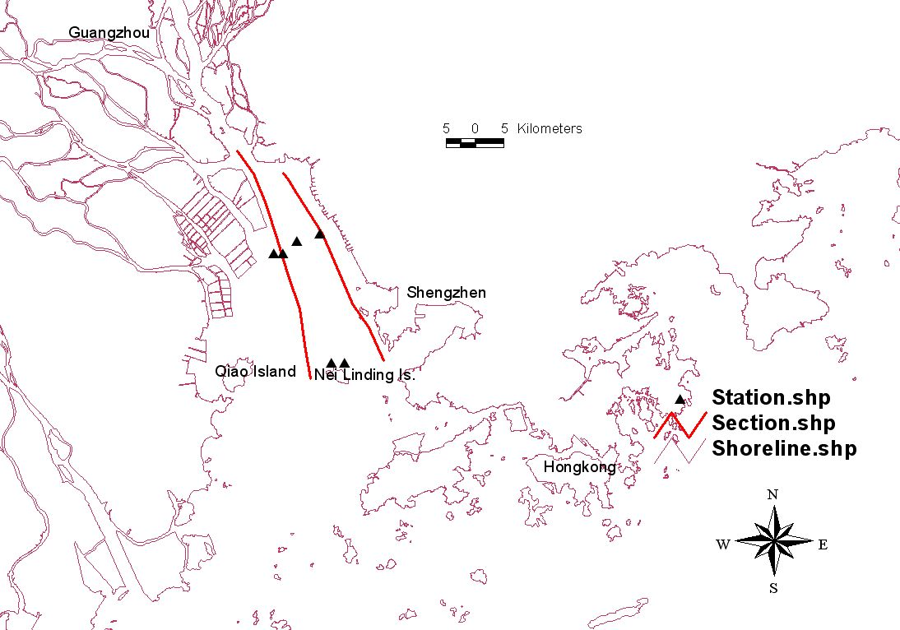
Figure 2: Stations and transects for field campaign in the Pearl River Estuary.

Innovation
The innovation is threefold. First, we particularly focus on obtaining a detailed understanding of the combined influence of lateral and longitudinal trapping, which is clearly not resolved by current modelling expertise. A second innovative aspect is the application to the Pearl River Estuary and the site-specific estuarine management problems experienced there. This will give insight in the role of the complex bathymetry of the Pearl River Estuary, a two-channel system with islands and four tributaries. The practical problems particularly deal with the response to extreme events (storms, river flooding) and human intervention (land reclamation, navigation dredging). Finally, our integrated approach leads to a generic idealized modelling tool, useful for a quick assessment of ETM dynamics in an estuarine environment.

The condition of morphodynamic equilibrium states that the tidally averaged sediment flux is non-divergent, i.e. not leading to bottom evolution. As an immediate consequence, the forcing must be non-episodic, i.e. either constant, periodic in time or a combination of both.

