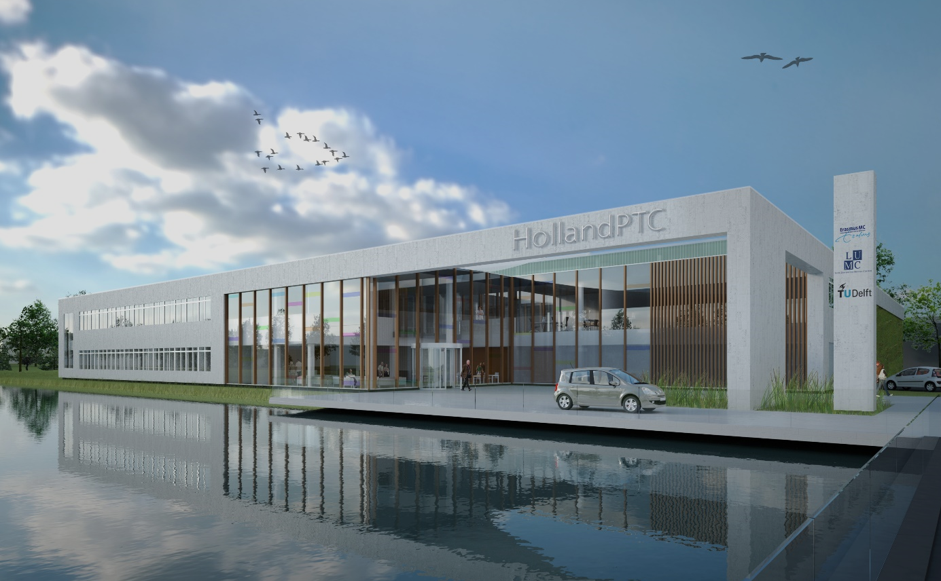
Advancing State-Of-The-Art Cancer Care: Student Projects in Proton Therapy

Proton therapy is currently being introduced to The Netherlands to provide cancer patients a cutting edge treatment option. Protons are uniquely capable to deliver dose to tumors with high precision, while avoiding healthy tissues as much as possible, thereby offer better chance for cure and fewer side effects compared to traditional radiotherapy. The Holland Proton Therapy Center (HollandPTC), being built right next to the campus of TU Delft will be one of the first Dutch centers, and is about to open its doors in early 2018.
Connected to this endeavor we have a number of interesting and challenging research projects, all aimed at bringing proton therapy closer to its full potential. Our research focuses on topics of the highest clinical relevance, such as improving planning protocols, developing novels ways to account for uncertainties, deriving new methods to evaluate the effectiveness of different treatment optimization methods, increasing the accuracy of dose calculations or exploring completely novel, biology-driven treatment planning approaches. As these projects require a thorough theoretical understanding of radiation physics, computational methods and relevant clinical knowledge, as well good practical skills in implementing new techniques, analyzing results and working with real patient data, they offer a perfect opportunity for students to advance their knowledge and experience. If you want to be part of an enthusiastic, collaborative group (involving members of TU Delft, Erasmus MC and HollandPTC), where you can learn, conduct cutting edge research, as well as see your results directly being used in practice to help cancer patients, you are definitely who we are looking for!
If interested in a project and joining us, or inquire about projects, do not hesitate to contact Dr. Danny Lathouwers (d.lathouwers@tudelft.nl), Dr. Zoltán Perkó (z.perko@tudelft.nl) or Dr. Martin van Gijzen (m.b.vangijzen@tudelft.nl).

Currently available projects:
1. Spatiotemporal optimization for prostate cancer patients
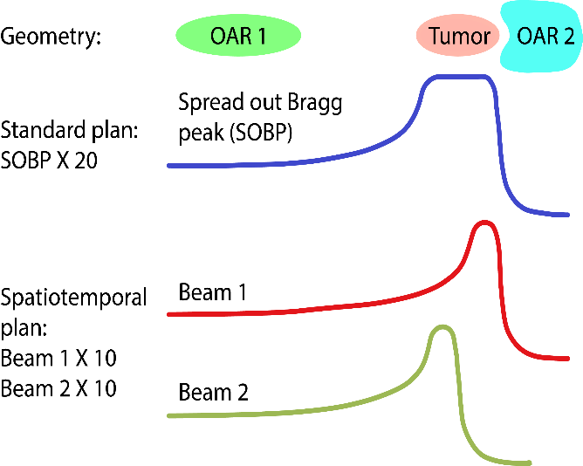
Cancer patients being treated with radiotherapy typically receive their treatment over the course of several weeks, during which dose is delivered in daily portions known as fractions. The rationale behind protracting the therapy is that healthy cells can typically recover from radiation damage better than cancer cells, therefore giving multiple smaller daily dose fractions instead of a few large doses (hypofractionation) increases the therapeutic ratio. For prostate patients however there is increasing evidence that hypofractionation may be more effective. Furthermore, it may be possible to design treatments where on different days, different parts of the tumor are treated with single high fraction doses, which ultimately may lead to better sparing of OARs. This is a highly promising new technique known as spatiotemporal optimization, and the aim of this project is to explore its feasibility and usefulness for prostate patients.
2. Probabilistic treatment planning for proton therapy
Proton therapy treatment planning is a complicated, computationally intensive procedure. It focuses on providing patients with personalized treatments that deliver high prescribed doses to target structures (tumors), while spare healthy organs as much as possible, which is achieved by choosing the optimal beam angles, proton energies and proton pencil beam intensities. Typically, beam angles are chosen manually by the treatment planners based on previous experience, whereas choosing the proton energies and pencil beam intensities leads to a large scale convex optimization problem (there are more than a million voxels in the patient, with thousands of available pencil beams whose intensities need to be optimized).
Conventional treatment planning only includes the nominal scenario, meaning that it is supposed that the anatomy of the patient is exactly identical on each day of the actual treatment. Since in reality this is clearly not true, and proton therapy is very sensitive to all sources of uncertainties (such as an error in the daily patient positioning, or the internal movement of organs between days), it is important to take into account such errors and their dosimetric effect. The goal of this project is to develop methods for probabilistic optimization, such as the errors scenarios can be included in treatment planning together with their occurrence probability. This would enable planning treatments that are robust against uncertainties (ensuring treatment success), are not over-conservative (minimizing normal tissue doses), and at the same time quantitatively takes into account errors and their effects. The research includes investigating and developing different probabilistic optimization approaches (such as expected value optimization or value-at-risk/conditional-value-at-risk optimization), testing the different methodologies on model cases as well as directly on real patient data, and implementing the developed techniques in the clinical treatment planning software to ensure the most realistic and accurate evaluation against current protocols.
3. A novel method for image reconstruction
In vivo molecular imaging is a discipline at the intersection of molecular biology and medical imaging, It is based on the use of biomarkers to probe molecular targets or pathways in living organisms without perturbing them. Imaging of biomarkers radiolabeled with isotopes that decay by positron emission, using positron emission tomography (PET), provides the best spatial resolution, molecular sensitivity (~10⁶ times better than fMRI) and quantitative accuracy available today. PET is based on the detection of the pairs of gamma rays created in the annihilation of positrons with electrons.

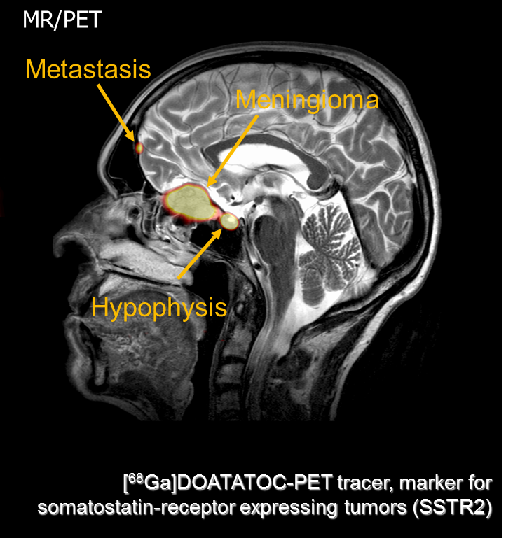

Project description
PET image reconstruction is practically based on first calculating the ‘system matrix’ that describes how each single voxel affects the detector response. This makes the problem discrete and can be done by a Monte Carlo code, taking as input the patient geometry and tissue properties (scattering, attenuation). This data, together with the actually measured response, is then used to reconstruct the source (i.e., the radiotracer concentration) in the body through a discrete optimization algorithm. Such iterative reconstruction algorithms are very time-consuming and may take up to several hours to complete.
Here we will investigate a completely new idea for source reconstruction. In this method we view the reconstruction as a continuous pde-constrained optimization problem that can be formulated precisely in terms of the radiation equations (the linear Boltzmann equation) describing the particle behavior from source to detector. This bypasses the necessity of the system matrix completely: after numerical solution of the set Karush-Kuhn-Tucker (KKT) optimization equations, the optimal source distribution is known. It is expected that this can be done in much less time than previously possible.

