Msc thesis proposal:

Derivation of characteristic functions for the purpose of pricing barrier options under the SABR model

Fang Fang

Background

The stochastic-alpha-beta-rho (SABR) model [8] is a popular stochastic volatility model in the financial industry, especially for the valuation of barrier options, which are of one of a few types of exotic options that remain liquid after the 2007~2008 credit crisis.

The SABR model is given by the following system of stochastic differential equations (SDEs) with constant parameters $α$ and $β$:
$${dS}_{t}=σ_{t}S_{t}^{β}dW_{1,t}$$
$${dσ}_{t}=ασ_{t}dW_{2,t}$$
Where $S_{t}$ is the asset price, $σ_{t}$ is the volatility, $W_{1,t}$ and $W_{2,t}$ are two Brownian motions with $E\left[dW_{1,t}dW_{2,t}\right]=ρdt$.

Monte Carlo simulation method and the PDE method are popular numerical methods in the financial industry when it comes to option pricing under stochastic volatility models, due to their simplicity and flexibility. However, the computational speed is very slow for both. Hence, the fast valuation of barrier options under the SABR model is still an interesting topic among market practitioners.

Quite a few papers published before 2008, such as [1], [2] and [3], proposed to tackle this problem via Fourier transform. The main idea is to find the characteristic function (ch.f) - the Fourier transform of the probability density function of the asset price – of the stochastic volatility model under consideration, and then, recover either the cumulative probability function or directly the option prices by means of Fourier inversion. However, the focuses there were on the Heston’s stochastic volatility model and other affine processes.

SABR model is not affine, which makes it challenging to derive the ch.f following the steps of [1]. It thus remains a gap in literature. However, once the ch.f. is available, one can price discretely-monitored barrier options using the COS method in the similar way as in [6].

A relatively recent paper published in 2017 [5] derived a closed-form approximation for pricing continuously monitored barrier options under the SABR model. The key idea there is to find an approximation of the PDE, of which the solution is the survival probability function of the asset price. It is thus interesting to see if the characteristic function of the survival density can be derived or recovered numerically. In case yes, then one can again apply the COS method [7] to easily price continuously monitored barrier options.

In summary, there is still a gap in literature regarding the derivation of the characteristic function of the asset price under the SABR stochastic volatility model, with or without the barrier/survival condition. Once this gap is bridged, one can apply the COS method to price either discretely or continuously monitored barrier options under the SABR stochastic volatility model.

This Msc thesis topic aims to bridge this gap.

Challenge

As mentioned earlier, the challenge lies in the derivation of the characteristic function of the asset price under the SABR model.

However, the SABR model has been studied extensively in literature and existing results can be used as building blocks for our derivations.

The goal and content of this thesis
The goal of this thesis project has two folds:
- derive the characteristic function of the asset price under the SABR model, with which one can apply the COS method to price discretely monitored barrier options in a similar way as in [6].
- Derive the characteristic function of the survival density of the asset price under the SABR model, with which one can apply the COS method to easily price continuously monitored barrier options as in [7].

Hence, this thesis consists of two parts.

- Part 1 – the main part

The first part of the thesis focuses on discretely monitored barrier options, for which we need to derive the characteristic function of the asset price under the SABR model. The approach is sketched below.

Note that the asset price dynamics of the SABR model follows the Constant Elasticity Variance (CEV) process, for a known path of the volatility, see below the cited proposition from [4].

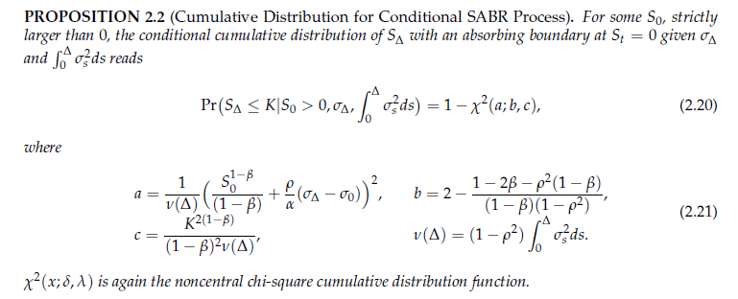

The above result gives a hint that we apply tower’s law on the expectation operator in the definition of the characteristic function, i.e.
$$ϕ\left(ω\right)=E\left[\exp\left(iωS_{Δ}\right)\right]=E\left[E\left[\exp\left(iωS_{Δ}\right)| S_{0},x,y\right]\right]=\int_{0}^{∞}{\int_{0}^{∞}{φ\left(ω|S_{0},x,y\right)f(x,y)dxdy}},$$
with $x=σ_{Δ}, y=\int_{0}^{Δ}{σ_{s}^{2}ds}$ and $φ\left(ω|S_{0},x,y\right)$ being the characteristic function of the conditional probability function cited above.

What remains to solve is the joint density function of $σ_{Δ}$and$\int_{0}^{Δ}{σ_{s}^{2}ds}$, or equivalently, its characteristic function. For this, we can take a similar route as presented in [2] and in the appendix of [3], i.e. we make use of the Feynman-Kac formula to write a PDE, of which the solution is the characteristic function under consideration, and then assume log-linearity of the solution to the PDE to yield a system of ODEs, which can be solved analytically or numerically.

- Part 2 – bonus part

The 2nd part of the thesis is to derive the ch.f. of the survival density. This is more difficult. The idea is to follow the steps of [5], i.e. apply the Lamperti transformation to yield a new model that has a constant volatility. Then we follow the steps of [2] to find the PDE of the ch.f. by applying the Feynman-Kac formula. What remains unknown is whether we could assume log-linear form for the solution so that we can transform the PDE to a systems of ODEs to solve.

Reference

- “Transform Analysis and Asset Pricing for Affine Jump-diffusions”, D. Duffie, J. Pan, K. Singleton, Econometrica, Vol. 68, No. 6 November, 2000, 1343~1376.
- “On the Valuation of Fader and Discrete Barrier Options in Heston’s Stochastic Volatility Model”, Susanne A. Griebsch and Uwe Wystup, No. 17 research paper of Frankfurt School of Finance & Management, 2008.
- “Exotic Options Pricing under Stochastic Volatility”, Nabil TAHANI, Canada Research Chair in Risk Management, Working paper 05-01, January 2005.
- “Efficient unbiased simulation scheme for the SABR stochastic volatility model”, Bin Chen, CornelisW. Oosterlee, Hans van der Weide. January 19, 2011.
- “Pricing Continuously Monitored Barrier Options under the SABR Model: A Closed‐Form Approximation”, Nian Yang, Yanchu Liu, and Zhenyu Cui, JMSE 2017, 2(2), 116–131.
- “A Fourier-based valuation method of Bermudan and Barrier options under Heston's model”, F. Fang and C. W. Oosterlee. SIAM J. Finan. Math. 2:439-463, 2011
- “A novel option pricing method based on Fourier-cosine series expansions”, F. Fang and C. W. Oosterlee. SIAM J. Sci. Comput.,31(2):826-848, 2008
- P. Hagan, D. Kumar, A. Lesniewski, D. Woodward, Managing smile risk, Wilmott Magazine (2002) 84–108.

Part-time Assistant professor at the Applied Mathematics Department of TU Delft; Director of FF Quant Advisory B.V. https://fsquaredquant.nl/
The COS method was introduced in [7] and is a highly efficient method to recover a probability density function (and European option prices) from the corresponding characteristic function.

